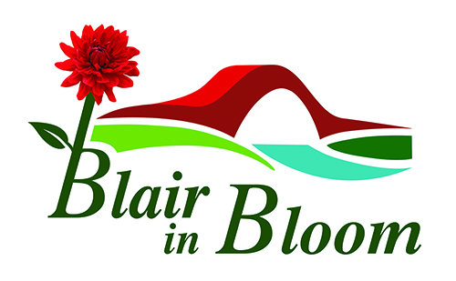
`Minutes of ‘Virtual’ Committee Meeting held on 5 April 2021
Present: Mary Birch, Cllr Bob Brawn, Ian Cruickshank, Pat Lumsden, Janine & Phil Seymour, Morag Reid, Avril & William Wilson

1 | Apologies  Cllr Caroline Shiers | Action
2. | Minutes of previous meeting held on 1 March 2021  Approved William Wilson, seconded Morag Reid
3. | Treasurer’s Report  Pat Lumsden confirmed a current balance of £4160.44, which included the two most recent donations of £100 from the Blairgowrie Ladies Tangent Group and Ericht Holiday Lodges respectively. A further £220 was banked from the sale of 9 street containers and two items kept for the pop-up shop.  The annual allocation from PKC was confirmed at £1800, plus £150 admin grant and £800 hanging basket compensation. Minus the cost of the plugs from Pentland Plants (£788.86) leaves a balance of just under £2000 to be spent by the end of November 2021. Phil to source the plant list from Peter Milne at Glendoick. | PS
4. | Matters arising  - Mary confirmed she had sent the annual report, constitution and volunteer policy to Steve Johnson for inclusion on the website. No further update received at time of meeting.  - Hanging baskets – Scott Macgregor from Blairgowrie Illuminations had contacted us to enquire if we proposed putting baskets on the bridge this year. BI are struggling to remove the Christmas lights due to Covid restrictions. It was agreed that for 2021 we would not put baskets on the bridge to give BI more time to be able to either remove the lights, or leave them in situ. It also gives us more time to adapt the poles to a more manageable height. Mary to contact Tom Caldow again re cost of watering. Also number of baskets to be confirmed, taking into account the ones normally put up by PKC. | MB
5. | Project updates  - Coronation Corner – contractors still to indicate when they will return to site. Price awaited for stainless steel handrails. Possibly enough left in budget to purchase 2 benches direct from manufacturer. Mary to chase up Chris Palmer & Butters.  - Rattray Church bed – edging to go in & more planting needed. | MB
 | Project update continued  - Ardblair – slabs stacked at Mount Ericht, which may need cutting/shaping to fit space. Ian has generator if required.  - Street containers – 6 left to rub down & paint. Pat will organise. William to measure for marine ply. Decision needed on what colour to paint.  - Elm Drive – roundabout. Phil to send contact details for Scotia Homes. Mary will write to see if they are willing to make a donation for either crocuses or roundabout. A project for next year though!  - Mount Ericht – Site now cleared by Bob Smith Contractors. Tam Miller is making security gates. Cost of site clearance and gates is included in the grant from SLF. An application submitted by BRDT to The Mushroom Trust for funding to go towards re-roofing of right-hand side building in courtyard. William to speak to Jimmy Neave re boundary wall identified in report as most in need of attention. Cllr Bob Brawn offered to check with PKC Planning if we had to apply for change of use from derelict garden to community garden. Probable cost of connecting utilities via Mount Ericht Lane would be £3/4000. Suggested a ring main be installed around perimeter wall.  - Parkhead Corner – train & bench to be painted. Paint to be bought. | PL/WW  PS  WW
6. | AOCB  - Pop-up shop at Howes from Friday 21 May 2021 for one week.  - Plant sale Saturday 5 June
 | Next Meeting  - Monday 3 May at 7pm. Mary to organise through Sam Stewart, ProComs for link. | MB

